Abstract

The purpose of Super Market Management System is to automate the existing manual system by the help of computerized equipment’s and full-fledged computer software, fulfilling their requirements, so that their valuable data/information can be stored for a longer period with easy accessing and manipulation of the same. The required software and hardware are easily available and easy to work with.

Super Market Management System, as described above, can lead to error free, secure, reliable and fast management system. It can assist the user to concentrate on their other activities rather to concentrate on the record keeping. Thus it will help organization in better utilization of resources. The organization can maintain computerized records without redundant entries. That means that one need not be distracted by information that is not relevant, while being able to reach the information.

The aim is to automate its existing manual system by the help of computerized equipments and full-fledged computer software, fulfilling their requirements, so that their valuable data/information can be stored for a longer period with easy accessing and manipulation of the same. Basically, the project describes how to manage for good performance and better services for the clients.

|  |  |
| --- | --- |
| **Particulars** | **Page no** |
| **CHAPTER 1 : INTRODUCTION** | 1 |
| * 1. Potential of the problem   2. Objective of the present work   3. Platforms and tools used |  |
| **CHAPTER 2: SYSTEM ANALYSIS** | 4 |
| * 1. Literature Survey   2. Finding of analysis      1. Existing system      2. Proposed system   3. System Requirement Specification (SRS)      1. Software Requirements      2. Hardware Requirements |  |
| **CHAPTER 3: DESIGN** | 8 |
| 3.1: Design of database(ER Diagram) 3.2: Schema Diagram   * 1. : Contex Diagram   2. : Design of user interface |  |
| **CHAPTER 4 : IMPLEMENTATION** | 12 |
| * 1. : Modules Implemented      1. : Detailed Design of Implementation 4.1.2: Technical Design Implementation |  |
| **CHAPTER 5: TESTING** | 13 |
| 5.1 Test cases |  |
| **CHAPTER 6: USER MANUAL AND SNAPSHOTS OF USER**  **INTERFACE** | 14 |
| 6.1: Database Connectivity with PHP 6.2: Snapshots  6.3: Code |  |
| **CHAPTER 7: CONCLUSION** | 18 |
| **REFERENCES** | 19 |

**Chapter 1: Introduction**

The Supermarket Management System is a project that deals with supermarket automation and it includes both purchasing a selling of items. This project is designed with a goal to making the existing system more informative, reliable, fast and easier. There are many reasons for the starting of the project because in the selling of items through the manual system of salesperson faces a lot of inefficiencies. It requires handling of large record books that consist of both irrelevant and important information’s thus making it difficult to find out the required information as per necessity.

The administrators consist of a unique password and names of the employees. It helps the employees to make secure login. The ids and passwords are kept secret from others. The modules of sales and purchase include all the details of selling and purchasing. In the billing module the details of payments are clearly shown.

The aim is to automate its existing manual system by the help of computerized equipment’s and full-fledged computer software, fulfilling their requirements, so that their valuable data/information can be stored for a longer period with easy accessing and manipulation of the same. Basically the project describes how to manage for good performance and better services for the clients.

This is one of the best system that can be introduced in the supermarket for efficient management. It will also reduce the cumbersome job of finding the most accurate data from the huge log books. It also helps the management to keep efficient records of all the purchases and sales. The introduction of ID and password will further reduce the manipulation and thus providing the accurate and transparent data. This system will increase the productivity and reduce the need of manual system to a large extent.

### Potential of the problem

In the existing system, all the works are to be done but in proposed system we have to computerize the work using this application.

* + - Ordering supplies.
    - Maintenance of supermarket

### Objective of the Present Work

The main objective of the Project on Super Market Management System is to manage the all details. It manages all the information about Products and managing categories, Product list, Customer list, Inventory, Supplier list, Receiving list and of individual user. The program to reduce the manual work. It tracks all the details about the Product and their details.

### Platforms and tools used

Platform forms the foundation on which the architecture, design, and implementation of a product is built. System specification defines the full functionality of the system. In many systems we work on, some functionality performed in hardware and some in software. System specification documents can thus be defined as the requirements documentation that formally specifies the system level requirements of an application. This application developed in Windows platform.

### PHP

* PHP is a recursive acronym for "PHP: Hypertext Preprocessor".
* PHP is a server side scripting language that is embedded in HTML. It is used to manage dynamic content, databases, session tracking, even build entire e- commerce sites.
* It is integrated with a number of popular databases, including MySQL, PostgreSQL, Oracle, Sybase, Informix, and Microsoft SQL Server.
* PHP is pleasingly zippy in its execution, especially when compiled as an Apache module on the Unix side. The MySQL server, once started, executes even very complex queries with huge result sets in record-setting time.
* PHP supports a large number of major protocols such as POP3, IMAP, and LDAP. PHP4 added support for Java and distributed object architectures (COM and CORBA), making n-tier development a possibility for the first time.
* PHP is forgiving: PHP language tries to be as forgiving as possible.



### My SQL

My SQL is the world's most used open source Relational Database Management system(RDBMS) as of 2008 that runs as a server providing multi- user access to a number of databases. It is named after co-founder Michael Widenius' daughter, My. The SQL phrase stands for Structured Query Language.

The My SQL development project has made its source code available under the terms of the GNU General Public License, as well as under a variety of proprietary agreements. My SQL was owned and sponsored by a single for-profit firm, the Swedish company MySQL Lab, now owned by Oracle Corporation.

**Chapter 2: System Analysis**

### Literature Survey

Retail modernization in developing countries and its effect on the broader food system has been a major focus of research since the early 2000s. The most visible banner for this work has been the “supermarket revolution”.

Supermarkets existed in Latin America from at least the 1960s, but began to grow much more rapidly in that region during the economic boom and opening to Foreign Direct Investment (FDI) of the 1990s. Growth began later in East/Southeast Asia and Central Europe, followed by selected countries of Africa (Reardon et al, 2004). This growth, together with new procurement practices that the firms work to apply, has led to a rash of studies attempting to document and anticipate the impacts of these firms on existing actors in the food system, and to draw policy implications for governments and donor

### Finding of analysis

System analysis is a process of gathering and interpreting facts, diagnosing problems and the information about the Supermarket Management System to recommend improvements on the system. It is a problem-solving activity that requires intensive communication between users. System analysis or study is an important phase of any system development process. The system is studied to the minutest detail and analyzed. The system analyst plays the role of the interrogator and dwells deep into the working of the present system. The system is viewed as a whole and the input to the system are identified. The outputs from the organizations are traced to the various processes. System analysis concerned with becoming aware of the problem, identifying the relevant and decisional variables, analyzing and synthesizing the various factors and determining an optimal or at least a satisfactory solution or program of action. A detailed study of the process must be made by various techniques like interviews, questionnaires etc. The data collected by these sources must be scrutinized to arrive to a conclusion. The conclusion is an understanding of how the system functions. This system is called the existing system. Now the existing system is subjected to close study and problem areas are identified. The designer now functions as a problem solver and tries to sort out the difficulties that the enterprise faces. The solutions are given as proposals. The proposal is presented to the user for an endorsement by the user.

The proposal is reviewed on user request and suitable changes are made. This is loop that ends soon as the user is satisfied with proposal. Preliminary study is the process of gathering and interpreting facts, using the information for further studies on the system. Preliminary study is problem solving activity that requires intensive communication between users and manager. It does various feasibility studies. In these studies, rough figure, the system activities can be obtained, from which the decision about the strategies to be followed for effective system study and analysis can be taken.

### Existing System of Supermarket Management System:

In the existing system the exams are done only manually but in proposed system we have to computerize the exams using this application.

* + - * Lack of security of data.
      * Time consuming.
      * No direct role for the higher officials

### Proposed System of Faculty Management System:

The aim proposed system is to develop a system of improved facilities. The proposed system can overcome all the limitations provides proper security and reduces the manual work.

* + - * Security of data.
      * Ensure data accuracy.
      * Proper control of the higher officials
      * Minimum time needed for the various processing
      * Greater efficiency.
      * Better service
      * User friendliness and
      * Minimum time required.

### System requirement specification

The Software Requirements Specification. produced at the culmination of the analysis task. The function and performance allocated to software as part of system engineering are refined by establishing complete information description, a detailed functional and behavioral description, an indication performance requirements and design constraints, appropriate validation criteria, and other data pertinent to requirements.

### Functional Requirements

* + - * Perform sales transaction
      * Generating a bill.
      * Update inventory.
      * Check inventory.
      * Update price.
      * Print sale statistics.
      * The manager selects the options to change the price of the product which updates the corresponding price in the database.
      * The programmatically determines the details of the product.
      * The display information about the product.

### Non-Functional Requirements

In this system, the authentication of the user is an important factor. In this system, user authentication will be done by login by user name and password and classified by user type. Users will get access to the system as permissions are classified for that type of user. The system has a consistent interface so that the system is easy to use and in the interface of our system buttons and forms are used to enter data related to a specific module.

### Software Requirements

|  |  |
| --- | --- |
| Operating System | Windows 7 & onwards |
| Language | PHP |
| Database | MySQL Server Version 8 |

* + - 1. **Hardware requirements**

|  |  |
| --- | --- |
| System | i3 1.5 GHz & onwards |
| Hard Disk | 100 GB |
| RAM | 4 GB |

**Chapter 3: Design**

### Design of Databases

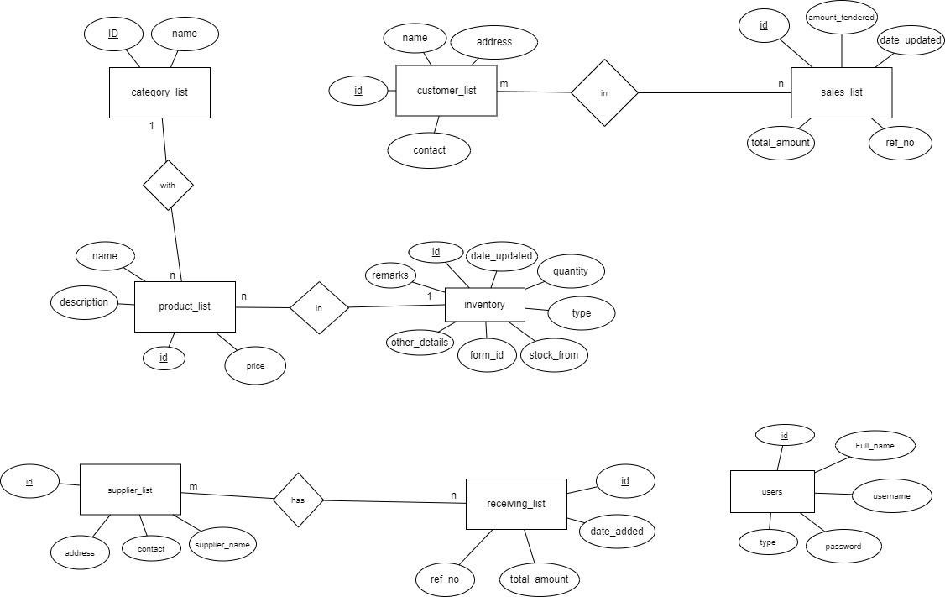

**Fig: ER Diagram**

* 1. **Schema Diagram**

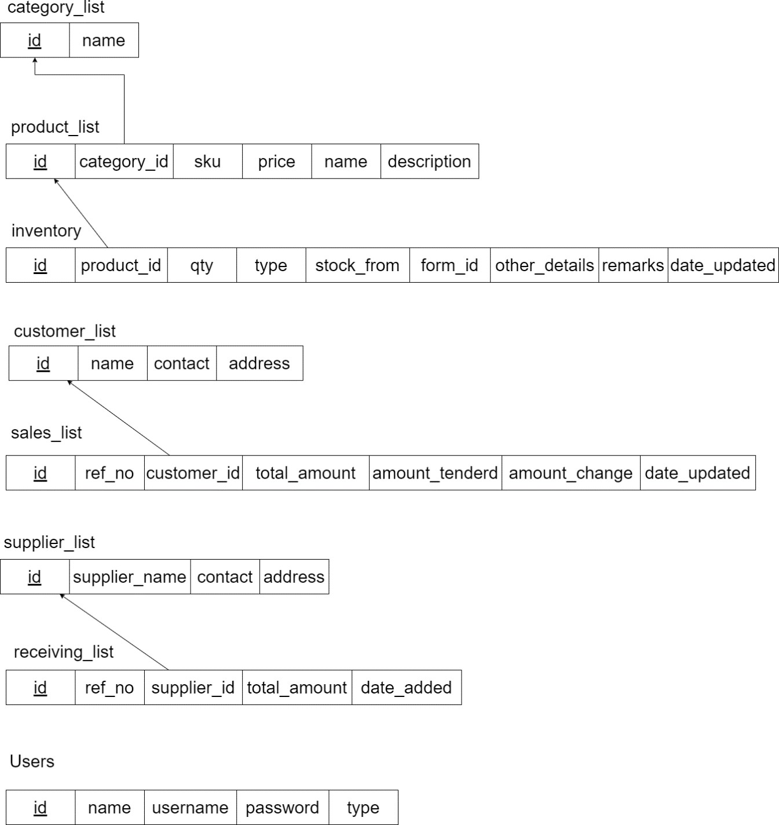

**Fig: Schema Diagram**

* 1. : Context Diagram
     1. : Context Diagram (DFD level 0)

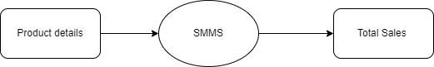

Fig: Context Diagram (DFD level 0)

* + 1. : Context Diagram (DFD level 1)

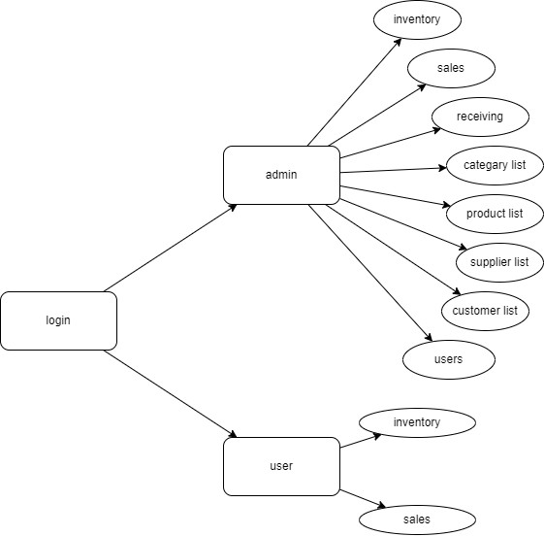

Fig:Context Diagram (DFD level 1)

* 1. **Design of User Interface**

User Interface Design is concerned with the dialogue between a user and the computer. It is concerned with everything from starting the system or logging into the system to the eventually presentation of desired inputs and outputs. The overall flow of screens and messages is called a dialogue.

The following steps are various guidelines for User Interface Design:

1. The system user should always be aware of what to do next.
2. The screen should be formatted so that various types information, instructions and messages always appear in the same general display area.
3. Message, instructions or information should be displayed long enough to allow the system user to read them.
4. Use display attributes sparingly.
5. Default values for fields and answers to be entered by the user should be specified.
6. A user should not be allowed to proceed without correcting an error.
7. The system user should never get an operating system message or fatal error.

**Chapter 4: Implementation**

### Modules Implemented Admin module

* + - **Inventory:** managing inventory, retailers meet customer demand without running out of stock or carrying excess supply.
    - **Sales:** selling the products and printing bill.
    - **Receiving:** receiving the product from the supplier.
    - **Categary list:** understanding entire categories rather than just knowing which stockkeeping unit sells well and putting that item on the shelf.
    - **Product list:** number of products are available.
    - **Supplier list:** There are lots of different kinds of retail suppliers that you can work.
    - **Customer list:** collect data about customers using loyalty cards which offer points whenever money is spent in the store.

### User module

* + - **Sales:** selling the products and printing bill.
    - **Inventory:** managing inventory, retailers meet customer demand without running out of stock or carrying excess supply.

### Detailed Design of Implementation

This phase of the systems development life cycle refines hardware and software specifications, establishes programming plans, trains users and implements extensive testing procedures, to evaluate design and operating specifications and/or provide the basis for further modification.

### Technical Design Implementation

This activity builds upon specifications produced during new system design, adding detailed technical specifications and documentation

**Chapter 5: Testing**

#### The steps involved during System testing are as follows:

* Integration of all the modules/forms in the system.
* Preparation of the test cases.
* Preparation of the possible test data with all the validation checks
* Actual testing is done manually.

Recording of all the reproduced errors , Modifications done for the errors found during testing

* Prepared the test result scripts after rectification of the errors

#### The System Testing done included the testing of the following items:

* Functionality of the entire system as a whole.
* User Interface of the system.
* Testing the dependent modules together with all the possible test data scripts.
* 8 Verification and Validation testing.
* Testing the reports with all its functionality

### 5.1 Test Cases

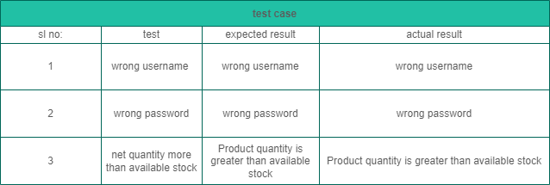

**Chapter 6: User Manual and Snapshots of User Interface**

### Database Connectivity with PHP

##### PhpMyAdmin

* + 1. Driver class: The driver class for the mysql database [http://localhost/phpmyadmin.](http://localhost/phpmyadmin)
    2. Connection URL: The connection URL for the mysql database is <http://localhost/Super>market , mysql is the database, localhost is the server name on which mysql is running, we may also use IP address 80, is the port number and faculty is the database name. We may use any database, in such case, we need to replace the Supermarket with our database name.
    3. Username: The default username for the mysql database is root.
    4. Password: It is the password given by the user at the time of installing the mysql database. In this example, we are going to use root as the password.

### Code

$('#manage-customer').submit(function(*e*){ e.preventDefault()

start_load()

$.ajax({

url:'ajax.php?action=save_customer', data: new FormData($(this)[0]), cache: false,

contentType: false, processData: false, method: 'POST', type: 'POST',

success:function(*resp*){

*if*(resp==1){

alert_toast("Data successfully added",'success') setTimeout(function(){

location.reload()

},1500)

}

*else if*(resp==2){

alert_toast("Data successfully updated",'success') setTimeout(function(){

location.reload()

},1500)

}

}

})

})

$('.edit_customer').click(function(){ start_load()

var cat = $('#manage-customer') cat.get(0).reset()

cat.find("[name='id']").val($(this).attr('data-id'))

cat.find("[name='name']").val($(this).attr('data-name'))

cat.find("[name='contact']").val($(this).attr('data-contact'))

cat.find("[name='address']").val($(this).attr('data-address')) end_load()

})

$('.delete_customer').click(function(){

_conf("Are you sure to delete this customer?","delete_customer",[$(this).attr('data-id')])

})

function delete_customer(*$id*){ start_load()

$.ajax({

url:'ajax.php?action=delete_customer', method:'POST',

data:{id:$id}, success:function(*resp*){

*if*(resp==1){

alert_toast("Data successfully deleted",'success') setTimeout(function(){

location.reload()

},1500)

}

}

})

}

* 1. **Snapshots**

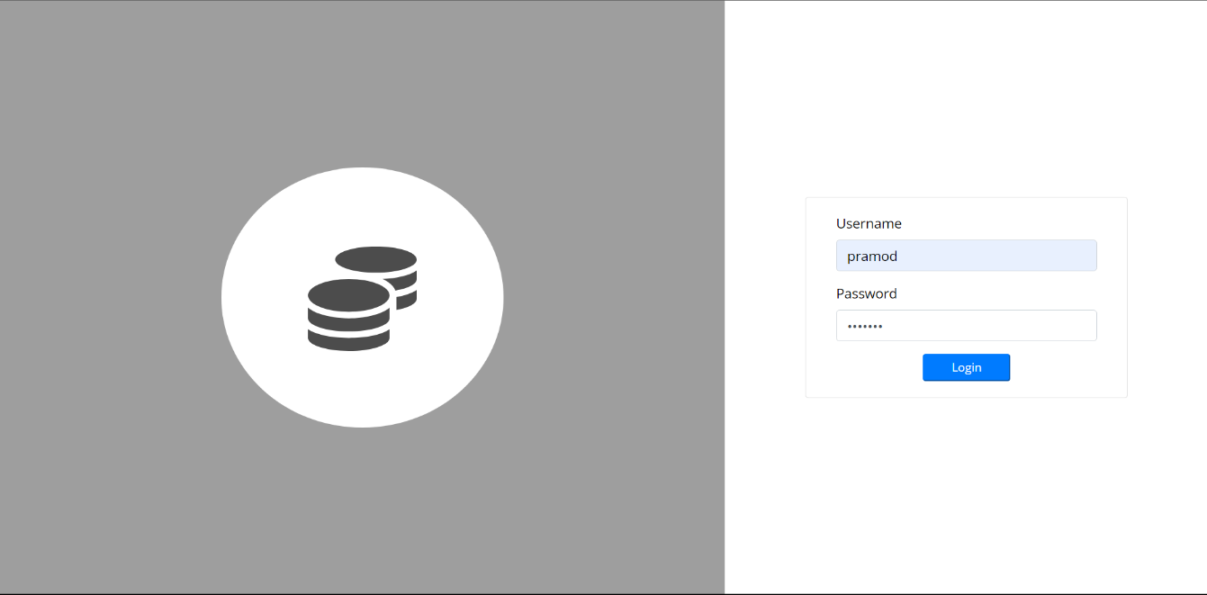

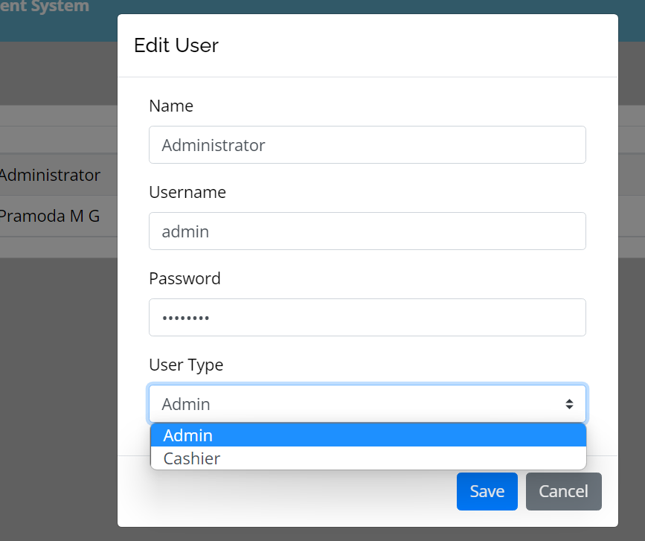

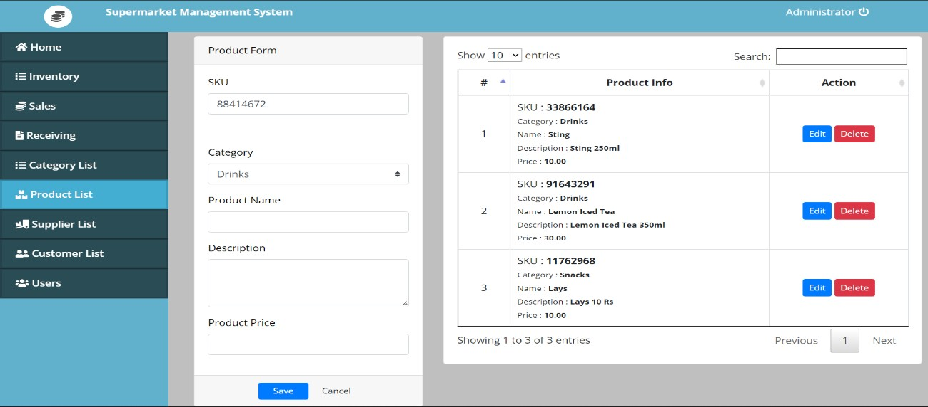

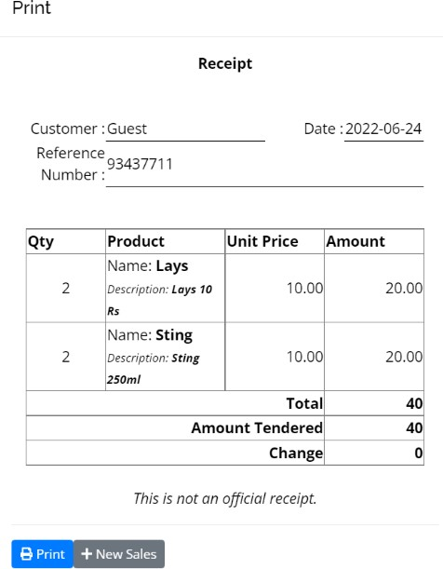

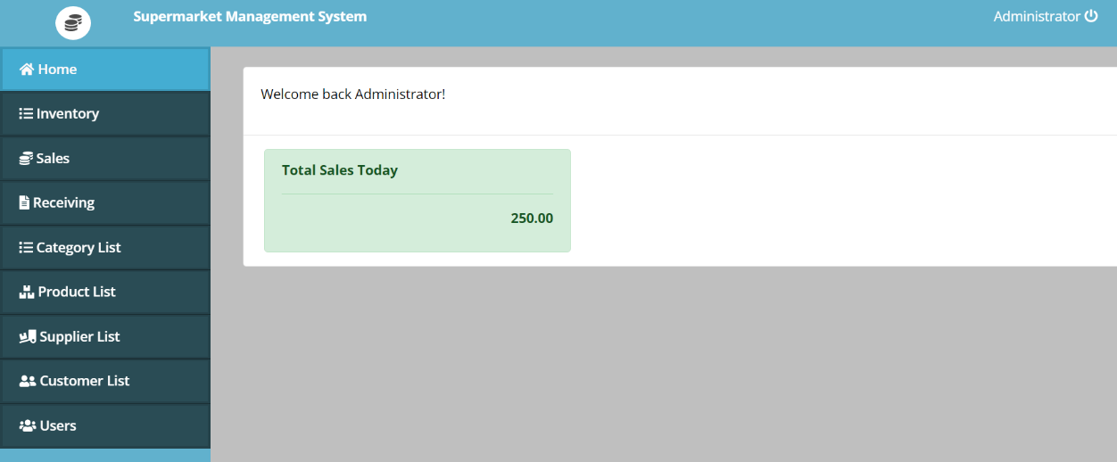

1. **Conclusion**

Reduce the time taken to handle the sales activity. It is designed to replace an existing manual record system for reducing time taken for calculations and for storing data. The system uses Visual Basic as front end and SQL server as a backend for the database.

The system is strong to handle daily operations where the database is cleared over certain time. This system will reduce manual work, calculations and will also provide periodic reports any time.

## References

* [**https://www.w3schools.com/php/php_examples.asp**](https://www.w3schools.com/php/php_examples.asp)**.**
* [**https://hevodata.com/learn/xampp-mysql**](https://hevodata.com/learn/xampp-mysql)**.**
* [**https://www.w3schools.com/w3css/defaulT.asp**](https://www.w3schools.com/w3css/defaulT.asp)
* [**https://www.w3schools.com/html/**](https://www.w3schools.com/html/)
* [**https://github.com/JackyChiu/Supermarket-Management- System/blob/master/public/index.html**](https://github.com/JackyChiu/Supermarket-Management-System/blob/master/public/index.html)
* [**https://code-projects.org/supermarket-management-system- project-report-in-php-css-js-and-mysql-free-download/**](https://code-projects.org/supermarket-management-system-project-report-in-php-css-js-and-mysql-free-download/)